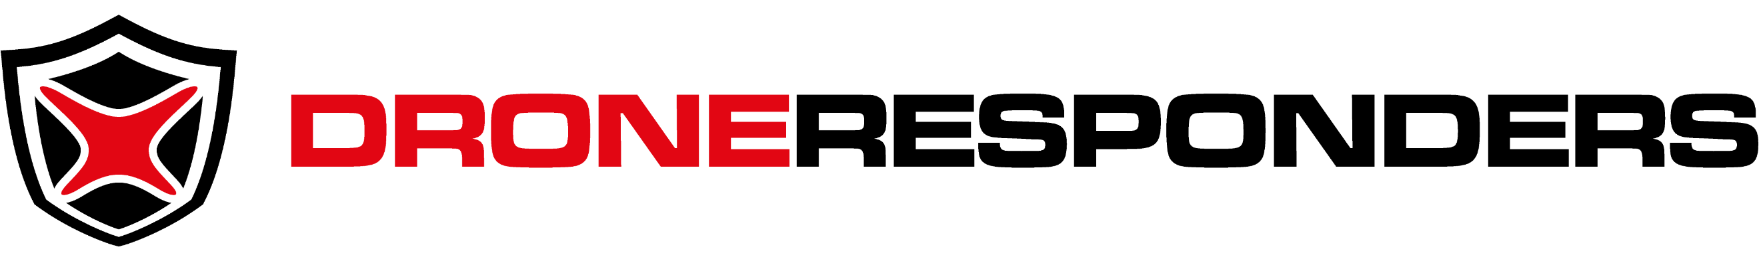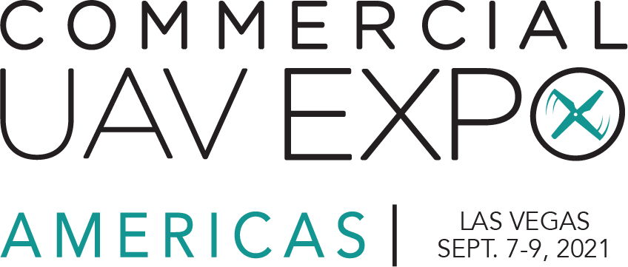

[DATE]

Dear [ADDRESSEE],

I respectfully request funding to attend the DRONERESPONDERS U.S. Public Safety UAS Summit at Commercial UAV Expo Americas in Las Vegas, Nevada from September 7-9, 2021.

This summit will unite public safety programs managers and operators of unmanned aircraft systems (UAS) from across the U.S. for two days of educational workshops and technology presentations that will help our agency develop a safer, more effective drone program to serve the public good.

In addition to the public safety UAS training and visibility our program will receive, I will have access to meet with solutions providers of the latest UAS technology on one of the largest exhibit floors in the unmanned systems industry. This will ensure our department has direct access to manufacturers and developers of the technology we use.

The full price of the U.S. Public Safety UAS Summit will full exhibit access is $249 if procured prior to July 16 ($299 thereafter). Additional projected travel costs are outlined below:

Summit/Conference Pass:
Airfare:
Ground Transportation:
Hotels:
Meals:
TOTAL FUNDING REQUEST:

Additional information on the DRONERESPONDERS 2021 U.S. Public Safety UAS Summit is available via http://summit.droneresponders.org

I thank you for your consideration of this training request to help ensure our department has one of the safest, most effective UAS programs in the nation.

Very Respectfully,

[Requestor Name, Title]

